SIMATS ENGINEERING
ASSESSMENT TOOL 1: Constraint-Based Problem Solving

COURSE NAME: | Cloud Computing and Big Data Analytics | COURSE CODE: | CSA1522

Register Number | Sanjay kumar soy
Name | 192311151

COURSE OUTCOME COVERED
CO5: Design big data processing systems using the Hadoop ecosystem including HDFS, MapReduce, and YARN. (BL5)

Dave's Taxonomy: Articulation (Level 4)  Question Count: 5 | Total Marks: 50

Code of Conduct
I sanjay kumar soy(192311151) certify that this submission is my original work and that I have adhered to the guidelines specified for this assessment.
I understand that any violation of academic integrity rules will result in disciplinary action.
Signature of the student:

Assessment Tasks
Constraint-Based Problem Solving
- Design an HDFS-based storage solution for a media platform under the constraints that data availability must remain above 99.9%, replication factor cannot exceed 3, and storage growth must stay cost efficient. Justify your design.
- A MapReduce workflow must process log data within a 20-minute batch window using limited cluster nodes. Propose a job design under these constraints and explain task distribution.
- A YARN-managed cluster supports ETL, reporting, and machine learning jobs. Design a scheduler policy under the constraints of fairness, priority for ETL, and recovery from node failure.
- An enterprise needs to ingest data from SAN, NAS, and operational databases into a big data platform while maintaining backup reliability and minimal duplication. Propose a constrained architecture and justify each component.
- Design an end-to-end Hadoop ecosystem solution under the constraints of secure data movement, high availability, and integration with Apache NiFi or ETL pipelines. Explain how your design satisfies all constraints.

Constraint-Based Problem Solving Rubric
Criteria | Weightage | Level 4 - Exemplary | Level 3 - Proficient | Level 2 - Developing | Level 1 - Beginning
Understanding of Constraints | 25% | All technical constraints are identified and prioritized accurately | Most constraints identified | Some constraints identified | Constraints poorly understood
System Design Quality | 25% | Design is robust, feasible, and aligned to constraints | Reasonable design | Basic design with gaps | Weak design
Application of Hadoop Concepts | 20% | Uses HDFS, MapReduce, YARN, and integration concepts effectively | Mostly effective use | Partial use of concepts | Weak concept application
Justification | 15% | Strong technical reasoning for all choices | Good justification | Basic justification | Little justification
Clarity | 15% | Clear, well-structured, and professional answer | Mostly clear | Somewhat unclear | Poorly structured

Answer
Q1) HDFS-Based Storage Solution for a Media Platform
A media platform stores large amounts of videos, images, audio files, thumbnails, and metadata. Since media data is continuously generated, the storage system must provide high availability, fault tolerance, scalability, and cost efficiency.
Proposed Architecture
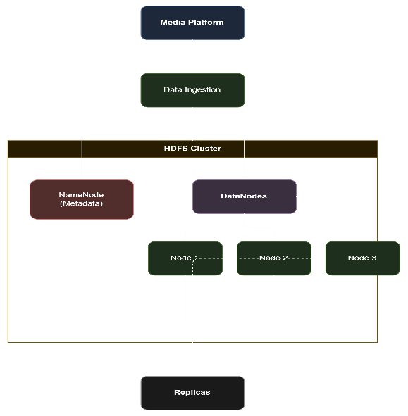

1. Replication Factor = 3
Set:
dfs.replication = 3
Each important media block is stored on three different DataNodes.
For example:
Video Block A
│
┌────┼────┐
↓ ↓ ↓
DN1 DN2 DN3
R1 R2 R3
If one DataNode fails, two copies are still available.
Justification: A replication factor of 3 provides strong fault tolerance while staying within the maximum allowed replication factor.
2. DataNode Failure Protection
DataNodes should be distributed across different racks.
Rack 1 Rack 2 Rack 3
DN1 DN2 DN3
│ │ │
└─ Same data block ────┘
HDFS rack awareness ensures that replicas are not unnecessarily placed on the same physical rack.
If one rack fails, another replica can still serve the data.
This improves availability toward the required >99.9% level.
3. High Availability for NameNode
The NameNode manages HDFS metadata and is therefore a critical component.
Use:
- Active NameNode
- Standby NameNode
- Shared/replicated edit information
- Automatic failover
HDFS Client
┌───────┴───────┐
↓ ↓
Active NameNode Standby NameNode
│ │
└───────┬───────┘
↓
DataNodes
If the Active NameNode fails, the Standby NameNode can take over.
Justification: NameNode high availability prevents a single metadata-server failure from making the entire HDFS cluster unavailable.
4. Cost-Efficient Storage Growth
The media platform will continuously generate new content. Therefore, the cluster should be horizontally scalable.
Instead of replacing existing servers with larger servers:
Existing Cluster
DN1 + DN2 + DN3
↓
Add DN4
↓
Add DN5
↓
Add DN6
New DataNodes can be added as storage requirements increase.
This follows a scale-out architecture, which is generally more cost-efficient for large media workloads.

5. Storage Tiers
Not all media needs the same performance.
Use different storage classes/tiering:
Data Type | Storage Strategy
Frequently accessed videos | High-performance storage
Recent images/audio | Standard HDFS storage
Old/rarely accessed media | Low-cost storage/archive
Temporary processing data | Reduced-cost temporary storage
Frequently accessed content remains readily available, while older content can be moved to cheaper storage.
6. Large File Optimization
Media files such as movies and videos are usually large.
HDFS is suitable because files are divided into large blocks and distributed across DataNodes.
For example:
Large Video
↓
Block 1 → DN1, DN2, DN3
Block 2 → DN2, DN3, DN4
Block 3 → DN3, DN4, DN5
This provides parallel access and distributes storage across the cluster.
7. Monitoring and Automatic Recovery
The cluster should continuously monitor DataNodes using HDFS health mechanisms.
If a DataNode fails:
DataNode Failure
↓
HDFS detects failure
↓
Missing replica detected
↓
Block re-replication
↓
Replication restored to 3
This ensures that temporary failures do not permanently reduce data availability.
Availability and Constraint Analysis
Requirement | Proposed Solution
Availability > 99.9% | 3 replicas + rack awareness + NameNode HA
Replication ≤ 3 | Replication factor = 3
Fault tolerance | Data replicated across DataNodes/racks
Cost efficiency | Scale-out DataNodes + storage tiering
Growing media data | Add DataNodes when capacity increases
NameNode failure | Active–Standby NameNodes
Large media files | Distributed HDFS block storage

The proposed solution uses an HDFS cluster with replication factor 3, rack-aware replica placement, NameNode high availability, automatic re-replication, and horizontal scaling. Three replicas provide fault tolerance without violating the replication constraint. Rack awareness and NameNode HA reduce single points of failure, helping the platform achieve the required greater than 99.9% availability. Finally, adding DataNodes incrementally and using storage tiering keeps the solution cost-efficient as media storage grows.

Q2. MapReduce Job Design for Log Processing
Suppose a system generates a large amount of web/server log data. The MapReduce job must process these logs within a 20-minute batch window, while the cluster has only a limited number of nodes.The objective is to design a MapReduce workflow that distributes the workload efficiently and completes within the given time.

Proposed Workflow
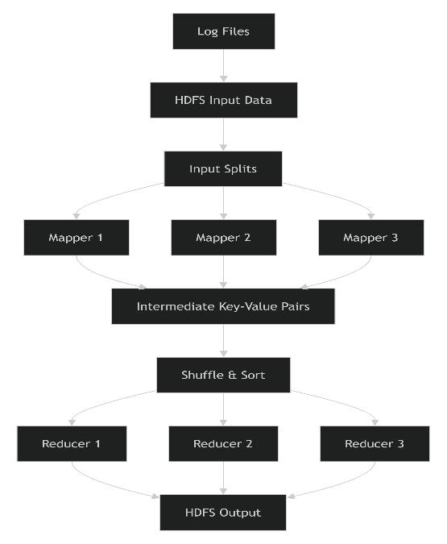
1. Input Data
Store the log files in HDFS.
Example:
/access/log1
/access/log2
/access/log3
Each log record may contain:
Timestamp | IP | URL | Status | Response_Time
For example:
10:20 | 192.168.1.10 | /home | 200 | 120ms
2. Input Splitting
HDFS divides the log files into input splits.
For example, if the logs are divided into 6 splits:
Split 1 → Mapper 1
Split 2 → Mapper 2
Split 3 → Mapper 3
Split 4 → Mapper 4
Split 5 → Mapper 5
Split 6 → Mapper 6
The number of mapper tasks can be greater than the number of physical nodes because Hadoop can execute tasks sequentially in available task slots.
3. Mapper Function
The Mapper reads each log record and generates key-value pairs.
For example, if the objective is to count HTTP status codes:
Input:
10:20 | 192.168.1.10 | /home | 200 | 120ms
Mapper output:
200 → 1
Another record:
500 → 1
So the Mapper essentially performs:
(key, value) = (status_code, 1)
4. Shuffle and Sort
Hadoop automatically performs shuffle and sort.
For example:
Mapper outputs:
200 → 1
500 → 1
200 → 1
404 → 1
200 → 1
After shuffle and sort:
200 → [1,1,1]
404 → [1]
500 → [1]
The same keys are sent to the same reducer.
5. Reducer Function
The Reducer adds the values.
200 → [1,1,1] → 3
404 → [1] → 1
500 → [1] → 1
Final output:
200 3
404 1
500 1
This can be used to identify successful requests, client errors, and server errors.

Task Distribution with Limited Nodes
Assume we have only 3 worker nodes.
Master
┌──────────┼──────────┐
↓ ↓ ↓
Node 1 Node 2 Node 3
M1,M4 M2,M5 M3,M6
R1 R2 R3
Here, six mapper tasks are distributed across three nodes.
Each node can process multiple tasks sequentially or concurrently depending on the available task slots.
Example Distribution
Node | Mapper Tasks | Reducer
Node 1 | M1, M4 | R1
Node 2 | M2, M5 | R2
Node 3 | M3, M6 | R3
This avoids requiring one physical node for every mapper.
Meeting the 20-Minute Constraint
To ensure completion within 20 minutes, the following strategies can be used:
1. Parallel Processing
Divide the logs into multiple input splits so that several mapper tasks process data simultaneously.
2. Data Locality
Run mapper tasks as close as possible to the HDFS blocks they process. This reduces network transfer time.
3. Appropriate Number of Reducers
Use enough reducers to prevent one reducer from becoming a bottleneck, but avoid creating excessive reducer tasks on a small cluster.
4. Combiners
Use a Combiner for operations such as counting.
Instead of sending:
200 → 1
200 → 1
200 → 1
over the network, the Combiner can locally produce:
200 → 3
This significantly reduces shuffle traffic.
5. Avoid Data Skew
If one key occurs much more frequently than others, a reducer may become overloaded. The input and partitioning strategy should therefore be monitored to prevent reducer bottlenecks.
Proposed 20-Minute Timeline
A possible target is:
Stage | Target Time
HDFS/input preparation | 1–2 min
Map phase | 7–8 min
Shuffle & Sort | 3–4 min
Reduce phase | 3–4 min
Output/overhead | 1–2 min
Total | ≤ 20 min
The exact timing depends on log size, hardware, network speed, and cluster configuration, so these are design targets rather than guaranteed times.
Final Design
Logs
↓
HDFS
↓
Input Splits
↓
Parallel Mappers
↓
Combiner
↓
Shuffle & Sort
↓
Parallel Reducers
↓
HDFS Output
Q3. YARN Scheduler Policy for ETL, Reporting and Machine Learning
A YARN-managed Hadoop cluster is used by three types of workloads:
- ETL jobs – need high priority because they prepare data for other applications.
- Reporting jobs – require predictable resources but can tolerate some delay.
- Machine Learning (ML) jobs – may require large amounts of CPU and memory and can run for longer periods.
The scheduler must provide fairness, give priority to ETL, and recover from node failures.
Proposed Architecture
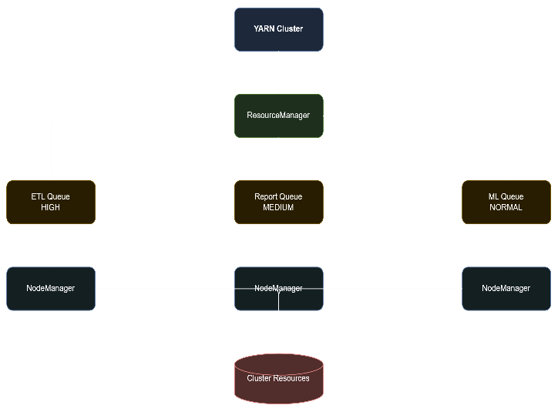
1. Queue Design
Create three YARN queues:
Queue | Priority | Purpose | Resource Allocation
ETL | High | Data extraction and transformation | 50%
Reporting | Medium | Business/analytical reports | 20%
ML | Normal | Training and ML workloads | 30%
The percentages represent capacity targets, not permanently reserved resources. Unused capacity can be borrowed by other queues.
2. ETL Priority
ETL jobs receive the highest priority because downstream reporting and ML jobs depend on processed data.
However, ETL should not completely starve reporting and ML workloads.
A minimum resource allocation can be maintained for each queue:
ETL → 50%
Reporting → 20%
ML → 30%
If ETL requires more resources, it can temporarily use unused resources from other queues.
3. Fairness
Within each queue, use Fair Scheduler policies or fair resource sharing.
For example, if two ML users submit jobs:
ML Queue
├── User A → 50%
└── User B → 50%
Instead of allowing one user to consume the entire ML queue, resources are shared fairly.
Similarly, reporting jobs from different departments should receive reasonable resource access.
4. Preventing Starvation
Priority should be combined with minimum resource guarantees.
5. Node Failure Recovery
YARN uses ResourceManager and NodeManager to monitor cluster health.
If a worker node fails:
NodeManager Failure
↓
ResourceManager detects failure
↓
Tasks on failed node identified
↓
Tasks restarted elsewhere
↓
Application continues
For example:
Before failure:
Node 1 → ETL Task 1
Node 2 → ETL Task 2
Node 3 → ML Task 1

Node 2 FAILS
↓
ETL Task 2 restarted
↓
Node 1 / Node 3 / available node
↓
Job continues
For long-running ML jobs, application-level checkpointing can also be used so that training can resume from a recent checkpoint instead of restarting completely.
6. Scheduler Policy
The overall scheduling policy can be:
IF ETL job is waiting
Give ETL high scheduling priority
Allocate up to its queue capacity
Allow borrowing of unused resources
ELSE
Share resources fairly among Reporting and ML
END IF
IF a node fails
Detect failed NodeManager
Mark resources unavailable
Restart affected tasks on healthy nodes
Restore normal scheduling
END IF
Example Scenario
Assume the cluster has 10 worker nodes.
Initially:
ETL → 5 nodes
Reporting → 2 nodes
ML → 3 nodes
If Reporting is idle:
ETL → 5 nodes
Reporting → 0 nodes
ML → 3 nodes
Unused → 2 nodes
The scheduler can temporarily give the unused resources to ETL or ML.
If a new ETL workload arrives, it receives priority and can obtain additional resources.
Policy Summary
Requirement | Scheduler Policy
ETL priority | High-priority ETL queue
Fairness | Fair sharing within queues
Reporting | Medium priority with minimum capacity
ML | Normal priority with minimum capacity
Resource utilization | Allow unused capacity to be borrowed
Node failure | Detect failed NodeManager and reschedule tasks
Long ML jobs | Checkpointing for faster recovery
Starvation prevention | Minimum capacity guarantees

. ETL receives the highest priority because it is critical to downstream processing, while Reporting and ML retain minimum resources to ensure fairness and prevent starvation. Unused resources are dynamically shared to improve utilization. If a node fails, YARN detects the failure and reschedules affected tasks on healthy nodes, while checkpointing can improve recovery for long-running ML jobs.Thus, the policy provides a balance between ETL priority, fair resource sharing, efficient utilization, and fault recovery.
Q4. Constrained Big Data Architecture for SAN, NAS and Operational Databases
An enterprise receives data from three different sources:
- SAN – high-speed block storage containing structured enterprise data.
- NAS – file-based storage containing documents, images, logs, and other unstructured data.
- Operational databases – transactional data such as customer, sales, and inventory records.
The architecture must provide reliable backup, minimal duplication, scalability, and efficient ingestion.
Proposed Architecture
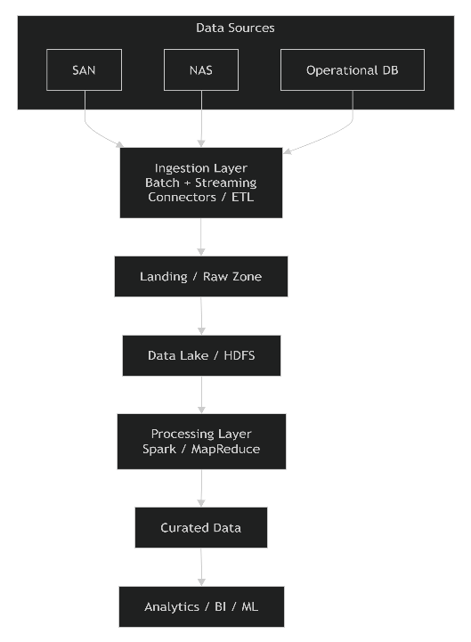
SAN Integration
SAN provides block-level storage and is commonly used for high-performance enterprise applications.
A suitable connector or ETL agent can read data from SAN-mounted systems and transfer only required datasets into the big data platform.
SAN → Ingestion Agent → Data Lake
- Preserves high-speed access to enterprise data.
- Avoids unnecessary movement of the complete SAN.
- Only required datasets are ingested.
NAS Integration
NAS provides file-level access.
Files such as:
- Images
- PDFs
- Documents
- Media
- Logs
can be ingested using file-based connectors.
NAS → File Ingestion → Raw Data Zone
The ingestion process should maintain the original file metadata.
Operational Database Integration
Operational databases should use incremental/CDC (Change Data Capture) rather than repeatedly copying the complete database.
Operational DB
↓
Change Data Capture
↓
Message/Ingestion Layer
↓
Data Lake
For example, instead of copying one million records every night, only newly inserted or updated records are transferred.
Justification
CDC:
- Reduces network traffic.
- Reduces processing time.
- Minimizes duplicate records.
- Reduces load on the operational database.
Ingestion Layer
Use a common ingestion layer to standardize data coming from SAN, NAS, and databases.
It can support:
- Batch ingestion
- Incremental ingestion
- Streaming ingestion
- Data validation
A metadata catalog should record:
Source
File/Table
Timestamp
Schema
Version
Checksum
This prevents the same data from being ingested repeatedly.
Raw/Landing Zone
Initially store the ingested data in a raw zone without modifying the original content.
Raw Zone
├── SAN
├── NAS
└── Operational DB
Each record/file should have a unique identifier or checksum.
For example:
File → SHA-256 checksum → Unique ID
If the same file appears again, the checksum can identify it as a duplicate.
It maintains the original data for recovery and auditing while preventing unnecessary duplicate copies.

Data Lake / HDFS
Use HDFS or a cloud data lake as the central big-data storage layer.
A logical structure could be:
/data
/raw
/san
/nas
/database

/processed
/customer
/sales
/inventory
HDFS provides distributed storage and fault tolerance.
For important datasets, a replication factor of 3 can be used, subject to the enterprise's storage constraints.
Deduplication
Minimal duplication can be achieved using three techniques:
A. CDC
For databases, ingest only changed records.
B. Checksum-Based Deduplication
For files from NAS/SAN:
File A → Hash 12345
File B → Hash 12345
Since the hashes match, File B can be identified as a duplicate.
C. Unique Record Keys
For database records:
Customer_ID + Last_Updated_Time
can be used to identify changes and prevent repeated copies.

Processing Layer
After ingestion, use a distributed processing framework such as Apache Spark.
Raw Data
↓
Spark Processing
↓
Cleaned Data
↓
Curated Data
Spark can perform:
- Data cleaning
- Transformation
- Deduplication
- Aggregation
- Data integration
Component Justification
Component | Purpose | Justification
SAN Connector | Ingest SAN data | Handles enterprise block-storage data
NAS Connector | Ingest files | Supports file-based/unstructured data
CDC Connector | Database ingestion | Transfers only changes
Ingestion Layer | Data collection | Standardizes multiple sources
Metadata Catalog | Track data | Prevents repeated ingestion
Raw Zone | Original data | Supports recovery and auditing
HDFS/Data Lake | Central storage | Scalable and fault tolerant
Deduplication | Remove duplicates | Saves storage and processing
Spark | Processing | Distributed transformation
Backup System | Disaster recovery | Protects against data loss
Off-site Backup | Disaster recovery | Protects against site failure

Constrained Architecture
The key constraint is minimal duplication, so the architecture should not create unnecessary copies at every stage.
A practical approach is:
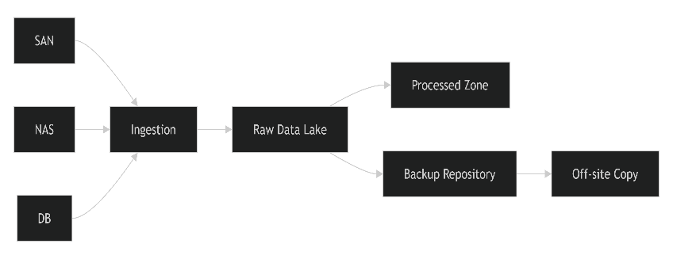
Only necessary copies are maintained:
- Raw copy – preserves source data.
- Processed copy – optimized for analytics.
- Backup copy – for disaster recovery.
Temporary processing copies should be deleted after successful processing.
The proposed architecture uses source-specific ingestion, CDC for operational databases, a centralized raw data lake, metadata-driven deduplication, distributed processing, and a reliable backup strategy. SAN and NAS data are ingested through appropriate connectors, while database changes are captured incrementally. Checksums and unique keys reduce duplicate data. HDFS/data-lake storage provides scalability and fault tolerance, while local and off-site backups provide recovery capability.
Thus, the architecture balances data integration, backup reliability, storage efficiency, and minimal duplication without unnecessarily replicating data across multiple layers.

Q5. End-to-End Hadoop Ecosystem Solution
Design an end-to-end Hadoop ecosystem for an enterprise that satisfies three major constraints:
- Secure data movement
- High availability
- Integration with Apache NiFi/ETL pipelines
1. Proposed Architecture
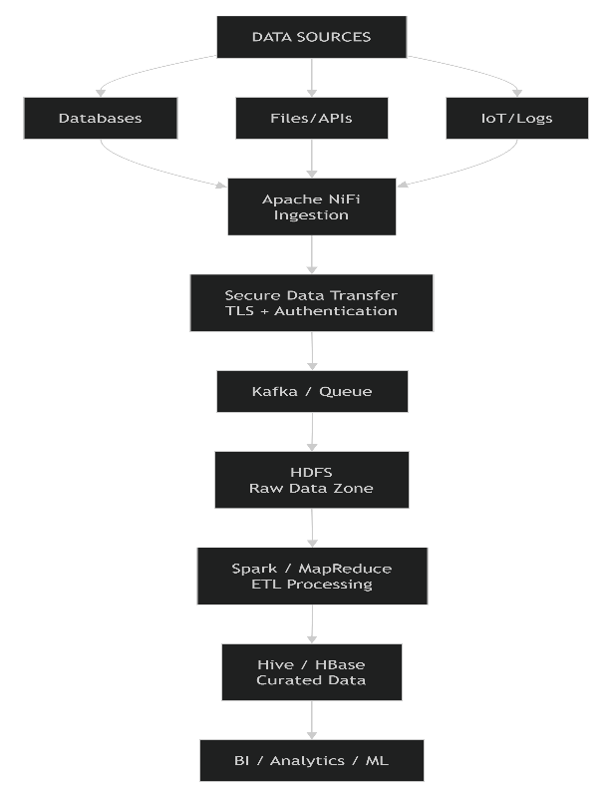

2. Data Ingestion Using Apache NiFi
Apache NiFi acts as the main data-ingestion layer.
It can collect data from:
- MySQL/Oracle databases
- CSV/JSON/XML files
- REST APIs
- Application logs
- IoT devices
NiFi provides a visual flow-based ETL mechanism and allows data to be routed, filtered, transformed, and monitored.
Example NiFi Pipeline
GetFile / QueryDatabase
↓
Validate
↓
TransformRecord
↓
Encrypt/Transmit
↓
PutHDFS

3. Secure Data Movement
Security should be implemented while data is moving between components.
A. TLS Encryption
Use TLS/SSL between NiFi, databases, Hadoop services, and other components.
Source
↓
Encrypted TLS connection
↓
Apache NiFi
↓
Encrypted connection
↓
HDFS
This prevents unauthorized users from reading data during transmission.
B. Authentication
Use authentication mechanisms such as Kerberos for Hadoop services.
Only authenticated users/services can access the cluster.
User/Service
↓
Kerberos Authentication
↓
Hadoop Services
C. Authorization
Use Apache Ranger or Hadoop permissions to control which users can access particular datasets.
For example:
User | HDFS Data
Admin | Full access
ETL User | Read/Write
Analyst | Read only
Guest | No sensitive-data access

4. HDFS Storage Layer
NiFi transfers the ingested data into HDFS.
Use a logical structure such as:
/data
/raw
/processed
/curated
/archive
The raw zone stores the original incoming data.
The processed zone contains cleaned and transformed data.
The curated zone contains data prepared for analytics.

5. High Availability
High availability means the system should continue operating even if a component fails.
NameNode HA
Use:
HDFS
|
┌──────┴──────┐
↓ ↓
Active Standby
NameNode NameNode
If the Active NameNode fails, the Standby NameNode can take over.
DataNode Fault Tolerance
Store HDFS blocks on multiple DataNodes.
For example, replication factor = 3:
Block A
├── DataNode 1
├── DataNode 2
└── DataNode 3
If one DataNode fails, another copy remains available.

6. NiFi High Availability
Deploy multiple NiFi nodes as a NiFi cluster.
NiFi Cluster
┌──────────┼──────────┐
↓ ↓ ↓
NiFi 1 NiFi 2 NiFi 3
└──────────┼──────────┘
↓
HDFS
If one NiFi node fails, other nodes can continue processing the data flow.
NiFi also provides back-pressure, which prevents downstream systems from being overwhelmed when data arrives faster than it can be processed.
7. ETL Processing
After data reaches HDFS, use Apache Spark or MapReduce for large-scale processing.
Raw HDFS Data
↓
Apache Spark
↓
Clean
↓
Transform
↓
Join
↓
Aggregate
↓
Curated HDFS Data
Spark is suitable for complex ETL operations because it supports distributed processing.
8. Hive for Data Warehousing
Use Apache Hive on top of the processed HDFS data.
Example:
SELECT department, AVG(salary)
FROM employee
GROUP BY department;
Hive allows analysts to query large datasets using SQL-like syntax.
9. HBase for Real-Time Access
If the application requires fast random read/write access, HBase can be used alongside HDFS.
For example:
HDFS → Large-scale analytics
HBase → Fast record lookup
This makes the Hadoop ecosystem suitable for both batch analytics and applications requiring low-latency access.
10. Monitoring and Failure Recovery
The architecture should continuously monitor:
- NiFi processors
- HDFS DataNodes
- NameNodes
- Spark jobs
- Network failures
- Storage capacity
If a failure occurs:
Component Failure
↓
Failure Detection
↓
Retry / Failover
↓
Continue Processing
NiFi can retry failed transfers, while Hadoop can recover from DataNode failures through replication.
Constraint Analysis
Constraint | Design Solution
Secure data movement | TLS/SSL encryption
Authentication | Kerberos
Authorization | Ranger/HDFS permissions
High availability | NameNode HA
DataNode failure | HDFS replication
NiFi failure | NiFi cluster
ETL integration | Apache NiFi
Large-scale processing | Spark/MapReduce
Data warehouse | Hive
Fast access | HBase
Monitoring | NiFi/Hadoop monitoring
Failure recovery | Replication + retry + failover

End-to-End Data Flow
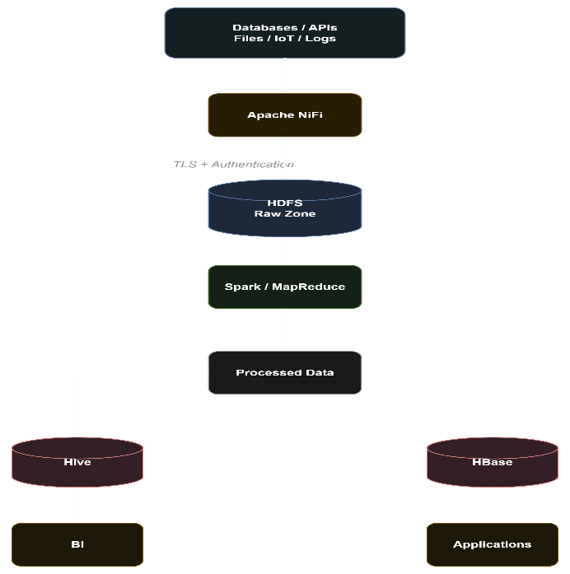
Therefore, the design satisfies all three constraints: secure movement through encryption and authentication, high availability through replication and failover, and seamless ETL integration through Apache NiFi.

